OUR BOOKS OF THE WEEK

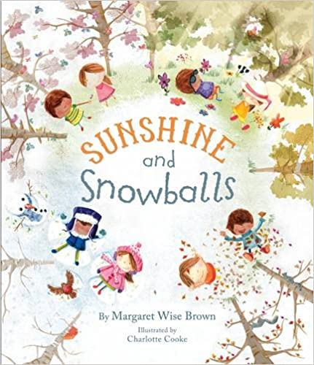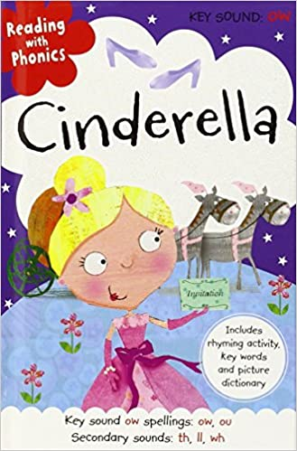 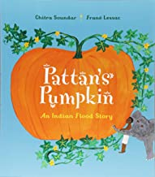 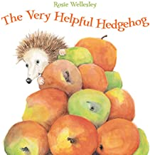 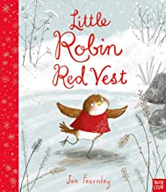 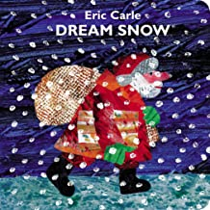

KEY VOCABULARY

|  |  |  |  |
| --- | --- | --- | --- |
| **AUTUMN** | Fungus, acorns, trees, leaves, autumnal, red, green, yellow, orange, chestnut, changing, crunchy, pumpkins | **WEATHER** | Sun, rain, hail, wind, bluster, whirling, rainbows, cold, mild, whistling |
| **WILDLIFE** | Squirrels, hedgehogs, badgers, foxes, owls, birds, migration, deer, rabbits, moles, mice, habitats | **SEASONS** | Days of the week, months of the year, spring, summer, autumn, winter. |
| **BONFIRE NIGHT** | Guy Fawkes, bonfire, pop, sparkle, bang, fizz, whiz flicker, zoom, houses of parliament, gunpowder, plot, loud, quiet | **CHRISTMAS** | God, Jesus, Mary, Joseph, stable, cattle, manger, shepherds, wise, wreath, crackers, stocking, bells, fairy lights, sleigh, reindeer, candle. |

AUTUMN

WHAT WE ARE LEARNING ABOUT

WE WILL BE:

* NAMING SEASONS AND NOTICING CHANGES.
* LOOKING AT CHANGES AND DESCRIBING WEATHER.
* LEARNING ABOUT WILDLIFE, HABITATS AND SURVIVAL.
* LEARNING THE DAYS OF THE WEEK AND THE MONTHS OF THE YEAR.
* EXPLORING STORIES AND TRADITIONS FROM LONG AGO.
* LEARNING HOW TO KEEP OURSELVES SAFE AROUND FIRE.
* GOING ON NATURE TRAILS AROUND OUR SCHOOL GROUNDS.
* PLAYING OUTDOORS IN ALL WEATHER CONDITIONS
* LEARNING ABOUT ARTIST ANDY GOLDSWORTHY AND USING HIS WORK TO INSPIRE OUR OWN.
* UNDERSTANDING WHY CHRISTIANS CELEBRATE CHRISTMAS.
* ACTING OUT THE CHRISTMAS STORY

EYFS CURRICULUM LEAFLET



RECEPTION CLASS

AUTUMN 2

PERSONAL, SOCIAL & EMOTIONAL DEVELOPMENT

WE WILL BE:

-LEARNING WAYS TO KEEP OURSEVES SAFE IN A RANGE OF SITUATIONS.

-TAKING CARE OF OUR OWN BELONGINGS.

YOU CAN HELP AT HOME BY:

-TALK TO ME ABOUT FIRE SAFETY AND BE A GOOD ROLE MODEL DAY TO DAY. EG. ‘I’M STANDING WELL AWAY FROM THIS BECAUSE IT IS HOT AND COULD BURN ME’.

LITERACY

WE WILL BE:

-BEGINNING TO HEAR SOUNDS IN WORDS

-RETELL A STORY USING ACTIONS

YOU CAN HELP AT HOME BY:

-SPOT GENERAL OBJECTS AROUND THEHOUSE AND MODEL THE FIRST SOUND IN THE WORD, E.G. ‘OH LOOK, AN APPLE, AN A A APPLE’

UNDERSTANDING THE WORLD

WE WILL BE:

-LEARNING TO RECOGNISE AND DESCRIBE OUR ENVIRONMENT AS SEASONS CHANGE.

- LEARNING ABOUT FAMOUS HISTORICAL EVENTS THAT SHAPE OUR CHRISTIAN TRADITIONS.

YOU CAN HELP AT HOME BY:

-TALKING TO ME ABOUT WEATHER AND NOTICING OUR NATURAL WORLD WHEN OUT AND ABOUT.

EXPRESSIVE ARTS

WE WILL BE:

-CREATING PICTURES AND PATTERNS BASED ON THE WORK OF ANDY GOLDSWORTHY

-ACTING OUT THE CHRISTMAS STORY

YOU CAN HELP AT HOME BY:

-CREATING YOUR OWN PATTERNS USING NATURAL MATERIALS IN THE GARDEN OR PARK.

-HELP ME TO SPEAK CONFIDENTLY AND WITH EXPRESSION.

MATHEMATICAL DEVELOPMENT

WE WILL BE:

-LEARNING ABOUT HALVES AND SHARING EQUALLY

YOU CAN HELP AT HOME BY:

-USE EVERY DAY OPPORTUNITIES TO ILLUSTRATE THE MEANING OF EQUAL AND HALVES. EG. WHEN EATING A PIZZA OR SHARING OUR SWEETS.

LANGUAGE & COMMUNICATION DEVELOPMENT

WE WILL BE:

-LEARNING TO SHARE IDEAS AND ASK QUESTIONS

-EXPLAIN PATTERNS AND CHANGE

YOU CAN HELP AT HOME BY:

-TALK TO ME ABOUT SEASINS AND WEATHER, ALLOW ME TO ASK HOW AND WHY QUESTIONS AND ANSWER THEM THE BEST YOU CAN.

PHYSICAL DEVELOPMENT

WE WILL BE:

-PERFECTING OUR PENCIL GRIP

-WORKING ON OUR SPACIAL AWARENESS AND NEGOTIATING SPACE SAFELY.

YOU CAN HELP AT HOME BY:

-CORRECTING MY PENCIL GRIP IF YOU SPOT ME HOLDING IT WRONG.