OUR BOOKS OF THE WEEK

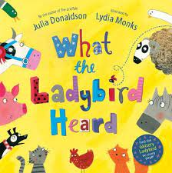 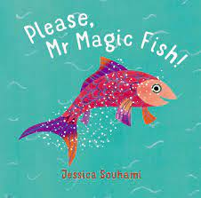

KEY VOCABULARY

|  |  |  |  |
| --- | --- | --- | --- |
| Beach | Sand, sandcastle, sun, shell, bucket, spade, bay, coast, dune, hat, sun cream, pier, shore, sunbathe, sunburn | Wildlife | Sea lion, crab, fish, dolphin, shark, whale, octopus, turtle, seahorse, walrus, eel, jellyfish, |
| Sea | Waves, tide, seaweed, coral, sea life, deep, shallow, marine | Tourism | Flight, aeroplane, coach trip, road trip, holiday, passport, arcade, beach shops, rock |

OH I DO LIKE TO BE BESIDE THE SEASIDE

WHAT WE ARE LEARNING ABOUT

WE WILL BE:

* LEARNING ABOUT SEASIDE TOWNS AT HOME & ABROAD
* LEARNING ABOUT HOLIDAYS IN THE PAST AND PRESENT
* FINDING OUT ABOUT SEA LIFE
* LOOKING AT SEASIDE ART
* HOW TOURISM HELPS EVERYBODY
* DIFFERENT WAYS OF TRAVEL
* ABOUT SEASIDEHOLIDAY TRADITIONS
* LEARNING HOW TO BE SAFE BY THE SEA
* LEARNING ABOUT LIGHTHOUSES AND THEIR PURPOSE
* LOOKING AT WHAT CAN HARM SEA LIFE

EYFS CURRICULUM LEAFLET

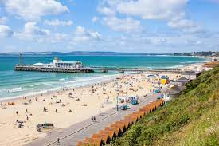

PERSONAL, SOCIAL & EMOTIONAL DEVELOPMENT

WE WILL BE:

-LEARNING WHAT IT MEANS TO BE HUMAN AND THE CAUSE AND EFFECT OF HUMAN BEHAVIOUR.

YOU CAN HELP AT HOME BY:

-HAVING A FAMILY CONVERSATION ABOUT SEASIDES, POLLUTION AND HOW OUR ACTIONS CAN CHANGE THINGS IN THE FUTURE.

LITERACY

WE WILL BE:

-WRITING SENTENCES INDEPENDENTLY.

-USING PHASE 3 AND 4 PHONICS TO INFORM BOTH MY READING AND WRITING.

YOU CAN HELP AT HOME BY:

-LEARNING MY PHONICS WITH ME TO HELP ME USE THEM IN MY READING AND WIRTING.

UNDERSTANDING THE WORLD

WE WILL BE:

-LOOKING AT OUR NATURAL WORLD AROUND US

-THE EFFECTS OF POLLUTION IN THE SEA

-WHO LIVES UNDER THE SEA

-SEASIDE PAST AND PRESENT

YOU CAN HELP AT HOME BY:

-READNG BOOKS WITH ME ABOUT THE SEASIDE AND THE SEA.

-LOOKING AT OLD PHOTOGRAPHS AOF SEASIDE HOLIDAYS.

EXPRESSIVE ARTS

WE WILL BE:

-LOOKING AT SEASIDE ART BY VARIOUS ARTISTS

-CREATING OUR OWN SEASDIE ART.

YOU CAN HELP AT HOME BY:

-SHOWING ME ARTISTS WORK AROUND SEASIDES IN AS MANY DIFFERENT STYLES AS POSSIBLE.

MATHEMATICAL DEVELOPMENT

WE WILL BE:

-LOOKING HOW TO ADD AND TAKE AWAY ONE USING FIRST, THEN, NOW TO HELP US

-LOOK AT PATTERNS WE CAN MAKE WITH SHPAES AND MAKING OUR OWN

YOU CAN HELP AT HOME BY:

-ASKING ME WHAT ONE MORE AND ONE LESS IS OF DIFFERENT NUMBERS

-ASKING ME WHAT DIFFERENT SHAPES I KNOW

LANGUAGE & COMMUNICATION DEVELOPMENT

WE WILL BE:

-LEARNING TO TALK CONFIDENTLY ABOUT THE SEASIDE AND HOW TO LOOK AFTER OUR COASTLINES.

-TALK ABOUT SEA LIFE AND HOW THEY LIVE.

YOU CAN HELP AT HOME BY:

-TAKE ME TO THE SEASIDE AND TALK TO MEABOUT WHAT I HAVE BEEN LEARNING

PHYSICAL DEVELOPMENT7

WE WILL BE:

-WORKING ON OUR HANDWRITING, MAKING IT NEATER AND GETTING READY FOR YEAR 1 FANCY WRITING (PRE-CURSIVE)

-WORKING ON OUR GROSS MOTOR SKILLS WITH LOTS OF OUTPLAY AND SPORTS

YOU CAN HELP AT HOME BY:

-HELP ME FORM MY LETTERS AND CORRECT THE FORMATION IF NEEDED.