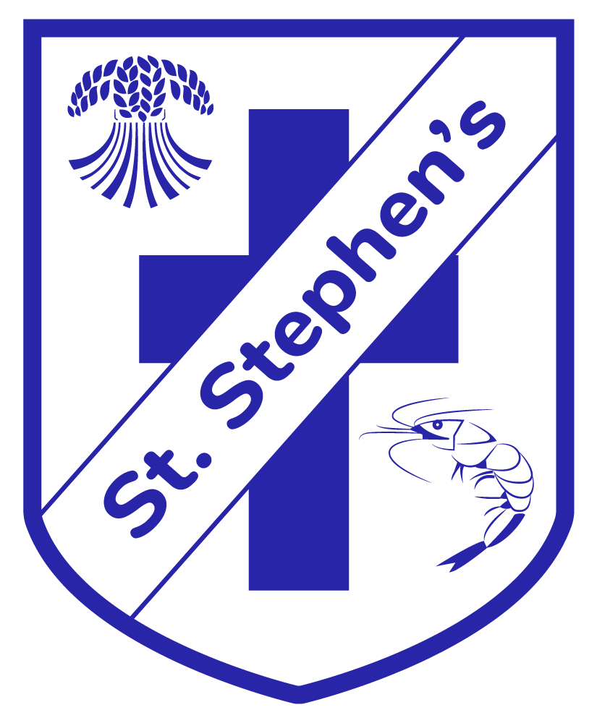

EARLY YEARS FOUNDATION STAGE POLICY
Intent
‘In the Early Years at Bank St Stephens Church of England Primary School we want children to be happy, confident, well rounded individuals with a love for learning. We believe in providing all children with a safe and stimulating environment that builds on each individual’s wants, needs and interests.

Learning through play should be fun, engaging and promote children’s natural curiosity whilst providing suitable challenge. We value the importance of our outdoor environment and believe that it offers children the opportunity to develop their thinking and problem solving skills.

We are committed to providing the best possible start to their school life, teaching them skills and giving them experiences which will ensure their well-being now and success in the future.’

Our Early Years Curriculum is based on the principles of child development and the educational programmes on the revised EYFS Statutory Framework 2021. It is planning to lead smoothly into the National Curriculum at KS1 in a way which is relevant and meaningful for all children.

The EYFS Curriculum stresses the importance of the prime areas of learning – the child’s personal, emotional and social development, the vital elements of communication and language and the role of physical development. It emphasises that the knowledge and skills in the specific areas of early literacy and numeracy, understanding the world and expressive art and design lay the foundations for the future learning of all children.

The EYFS framework is organised into seven areas of learning and development, all of which are interdependent and of equal importance;

Prime:
Personal, social and emotional development – involves helping children to develop a positive sense of themselves, and others; to form positive relationships and develop respect for others; to develop social skills and learn how to manage their feelings; to understand appropriate behaviour in groups; and to have confidence in their own abilities.

Communication & Language – involve giving children opportunities to experience a rich language environment; to develop their confidence and skill in expressing themselves; and to speak and listen to a range of situations.

Physical Development – involves providing opportunities for young children to be active and interactive; and to develop their co-ordination, control, and movement. Children must also be helped to understand the importance of physical activity and to make healthier choices in relation to food.

Specific:
Literacy – involves encouraging children to link sounds and letters and to begin to read and write. Children must be given access to a wide range of reading materials (books, poems, and other written materials) to ignite their interest.

Mathematics - involves providing children with opportunities to develop and improve their skills in counting, understanding and using numbers, calculating simple addition and subtraction problems; and to describe shapes, spaces, and measure.
Understanding the world - involves guiding children to make sense of their physical world and their community through opportunities to explore, observe and find out about people, places, technology and the environment
Expressive arts and design - involves enabling children to explore and play with a wide range of media and materials, as well as providing opportunities and encouragement for sharing their thoughts, ideas and feelings through a variety of activities in art, music, movement, dance, role-play, and design and technology.
For key learning, skills covered and opportunities across the EYFS department please refer to the Nursery and Reception Curriculum Overview Documents.

Implementation
In line with the key principles of the EYFS (unique child, positive relationships, enabling environments, learning and development, safeguarding, assessment) our practice starts with the child and their individual/cognitive development. We observe and assess children on-entry to determine their needs, interests, abilities and skills which we use to develop our curriculum. We offer a play based curriculum inside and outside the classroom which is carefully organised and planned for and includes opportunities for children to develop knowledge and skills through a wide range of opportunities and experiences. Play is fundamental to children’s development, building their confidence as they learn to explore, to think about problems and relate to others.
We use Development Matters 2021, Birth to Five 2021 and Lancashire EYFS Curriculum planning Framework to assist us when planning provision to support learning and development across all seven areas of learning and when planning for Characteristics of Effective Learning.
Our pedagogy is founded on the needs and interests of the children, we use the core book approach to give all children a love of reading and a wide variety of vocabulary. We aim to ensure children’s access to a diverse and appropriate range of books containing exciting and gripping stories, evocative and fascinating language, thought provoking imagery and situations which will develop their imaginations, understanding of the world, emotional resilience and empath.
Our curriculum is implemented in a considered structured way, by staff modelling and teaching in continuous provision using activities which develop to develop children’s skills, knowledge and understanding. This adult led/adult guided learning enables them to learning independently in continuous provision, building on, practising and developing what they have been working on. Children’s interests are developed through areas/stations created in different areas of our indoor and outdoor environment.
Weekly Forest School sessions sets learning in a different context where they undertake a range of activities and carry out small achievable tasks. Children develop their team building skills and also become more independent. Their experience can also help to lead to the development of healthier lifestyles and the children gain confidence and improve their self-esteem, this can impact on their emotional and mental well-being too.
Key Learning is developed through children’s interests, topics and themes in continuous provision, adult led and adult guided learning and is sequenced through observation, assessment and planning. The curriculum at Banks St Stephens has been developed in line with the EYFS requirements, including The Characteristics of Effective Learning and careful coverage using the Lancashire Framework for Planning to ensure each area of learning is planned for and essential skills and knowledge are covered.
EYFS Planning
At St Stephens our planning includes:
Long Term Plan/Curriculum Overview: An overview of learning, predictable themes, topics and core texts. It also includes the skills we will be covering in these areas using The Early Years Foundation Stage Curriculum, Birth to Five, Development Matters and the Lancashire Planning Document.
Short Term Planning: We continually use an observation, assessment and planning cycle to determine the children’s starting points, needs and interests. Short term planning is responsive to the children’s needs/fascinations and provides a weekly overview of the implementation of the curriculum through teaching and learning activities covering the seven areas of learning and opportunities for the development of the Characteristics of Effective Learning.
This would include knowledge of prior learning, specific planning to meet the requirements of the seven areas of learning and development, mental maths, phonics and the locally agreed RE syllabus. Planning for adult led or adult guided activities, enhancements in continuous provision, activities to support observed interests of the children.

Impact
At St Stephens we are working towards all children achieving the Early Learning Goals by the end of reception year. Development Matters age related bands and Birth to Five ranges help staff identify children’s developing knowledge, skills, understanding and attitudes as they make progress towards the early learning goals, throughout the foundation stage.

Observation and Assessment
On Entry Assessment
Children are assessed in many ways as they enter the Foundation Stage at Banks St Stephens Primary School. They are assessed on a one-to-one basis with the class teacher to inform the teacher with a starting point for the child’s learning. A statutory baseline assessment is carried out on all children after at the beginning of the reception year after the children have settled in. The assessments are carried out by the class teacher in the form of a child friendly computer program, this helps to inform teacher assessment and results are reported nationally by the school. Information is gathered from previous settings, parents and other professionals and transition documents are passed up from other childcare settings. Samples of children’s work along with photographs are kept to use as evidence and further assessment. Evidence throughout the year is kept in Learning Journey’s and Seesaw accounts for each child and tracked throughout the year.
Formative Assessment
Observations, photographs, and children’s work are recorded in a way chosen by teachers and practitioners to ensure they are working smart and are able to make professional judgement on whether the children are emerging or at the age related expectation. Assessment is used by practitioners to develop knowledge of individual progress, in order to inform future planning, e.g. talking to and listening to children, discussion with parents and participating in activities.
Summative Assessment
We use summative assessment in our setting to ensure that:
- Practitioners have a clear understanding of a child’s progress across all areas of learning and development.
- Parents understand their child’s progress and are helped to support learning and development at home.
- Concerns about individual children’s progress are identified and addressed.
- The quality of provision is monitored and improvements made where necessary.
- The progress of groups of children can be monitored to make sure they are being given the best opportunities to learn.
- The staff have the skills and knowledge they need to enable the children to make progress.

Statutory assessment for reception is the EYFSP (Early Years Foundation Stage Profile) which takes place at the end of the school year in reception and is reported to the local authority.
The transition period between both nursery and reception and nursery and year 1 is taken very seriously. Meetings with staff either side are arranged and the children are individually discussed at great length. Evidence is passed up to support the assessment and all tracking is used to support it. Characteristics of Learning forms are also filled in and passed up to the appropriate teacher to ensure every child’s learning style is catered for. The children are assessed against all 17 Early Learning Goals in each of the 7 areas of learning and a simple tracker is used to record this data.

Reporting to Parents
At the end of the reception year, schools must share the results of the Profile with parents to inform them of their child’s progress towards the Early Learning Goals and the profile must be completed for all children, including those with SEN or disabilities.
Information is shared between staff and parents on an on-going basis throughout the year;
- Through interactions and the beginning and the end of each day
- Home visits
- Parents evenings
- Magic Moments
- Stay and Play Visits
- Reports
- Open evenings and afternoons
- Learning journeys
- Open door policy
- Home/school communication slips
- Seesaw

Induction/Parental Engagement & Involvement
When children come to St Stephens CE Primary School they are inducted carefully and personally by the staff. They are given a welcome pack which contains the following;
- Important dates, induction visit information etc
- School prospectus
- A brief explanation of the reception daily routine and what and how their child will be learning.
- Uniform list and order form
- Contact details form
- Emergency procedures information
- Booklet on the importance of learning at home
- Named people allowed to pick the child up from school

The parents are invited to open evenings throughout the year and once their school is confirmed they will be invited in to meet the staff and have a short presentation where they will learn about how their child will start school and important information they might need. Parents are informed about how the EYFS is delivered in the setting and how they can support their children at home and a run through of relevant policies and procedures followed by the school. We discuss how children with specific needs are catered for and are supported and give details of where relevant policies can be accessed by parents.
The children are invited in to school for two visits prior to the summer holidays to meet the staff and explore the classroom. They are then offered home visits at the initial meeting and these will also take place before the summer holidays commence. The class teacher and the teaching assistant visit the children in their own home to discuss any further details and meet the child personally, this is to establish good relationships with the child in their ‘safe places’ and ensure the transition process is as smooth as possible. These procedures are changed and adapted according to the individual needs of the child.

Transition Procedures
Nursery to Fox Cubs Nursery – Our nursery teacher aims to induct children into Fox Cubs Nursery happily and smoothly. The process includes liaison with home/previous nursery settings where information is transferred, visits to previous nursery settings/homes, meet the teacher evening, stay and play visits and identification of key person and other staff. Procedures are adapted according to the needs of the individual child.
Preschool to Reception - Some children may already attend our nursery in which case they will already be familiar to the setting, children and staff. The induction process is the same for children and families who attended Fox Cubs Nursery and are new to school as we still value the importance of getting to know our children and families properly. We start by inviting parents and carers in for an induction meeting where we will tell them all about Reception Class routines and curriculum, information about the school and who is who. We follow this meeting offering home visits to allow us to meet children and parents in their own homes to give them a sense of security with their familiar adults. We then invite parents and children in for stay and play visits to see their classroom and meet their new classmates. Procedures are adapted according to the needs of the individual child.
Reception to Year 1 – Our teachers and staff work very closely in ensuring information is passed on from class to class. A meeting is organised at the end of each academic year where teachers will discuss each child’s learning, needs, and learning styles at length. Children take part in moving up days in school, identification of key staff and stay and play sessions in their new classrooms. The parents are invited in to discuss any concerns and are informed of the main changes of the national curriculum and the more structured approach to learning with still some elements of the EYFS.

